CYBERSECURITY INTERNSHIP PROJECT REPORT
Project Title:
Sentinel Shield – Web Security & Threat Detection System

Submitted By:
Arshi

Internship Organization:
Unified Mentor.Com

Duration:
6 Months Internship

Year:
2026

TABLE OF CONTENTS

1. Cover Page ............................................. 1

2. Introduction ........................................... 3

3. Technologies Used & Tools Used............... 3

4. GitHub Repository ...................................... 3

5. Live Deployment Link ................................... 3

6. Project Screenshots ................................. 4-5

7. Learning Outcomes .................................... 5

8. Conclusion ............................................ 6

Introduction : This project focuses on cybersecurity and web application protection.
The main objective is to identify vulnerabilities, improve security monitoring,
and provide protection against cyber threats using modern cybersecurity tools and techniques.
Technologies Used :
• Kali Linux
• Nmap
• Wireshark
• HTML/CSS/JavaScript
• Node.js
• Vercel Deployment
• GitHub
GitHub Repository
https://github.com/Arshizehra786/Sentinel-Shield-Advanced-Intrusion-Detection-Web-Protection-System-
Live Project
https://vercel.com/arshizehra786s-projects/sentinel-shield-advanced-intrusion-detection-web-protection-system

Prectical Screenshots
Kali Linux environment setup and installation process used for cybersecurity testing, ethical hacking practice, and deployment preparation during the internship project.
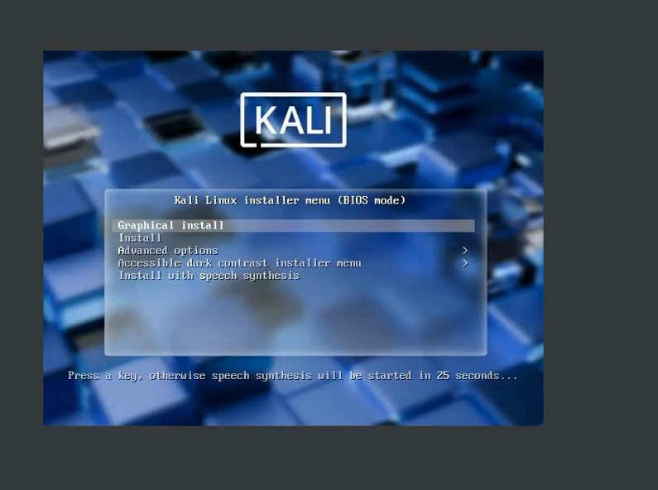

Created and managed project directories in the Kali Linux virtual environment as part of the cybersecurity internship practical setup and deployment workflow.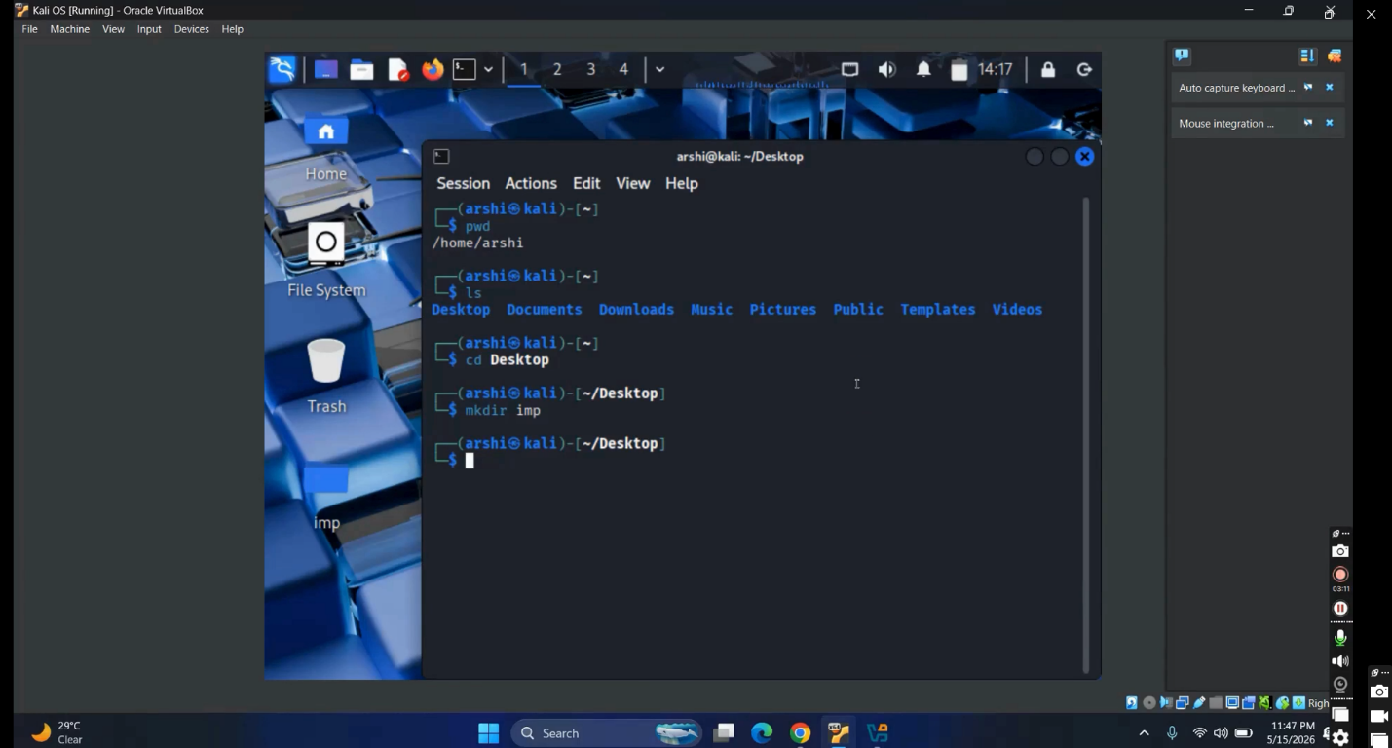

The OSINT Framework was deployed successfully, providing a centralized interface for open-source intelligence gathering. The tool organizes resources into categories such as usernames, domains, IP addresses, social networks, and public records, enabling streamlined investigations and efficient data collection. The deployment ensures accessibility with a simple search function and intuitive navigation.
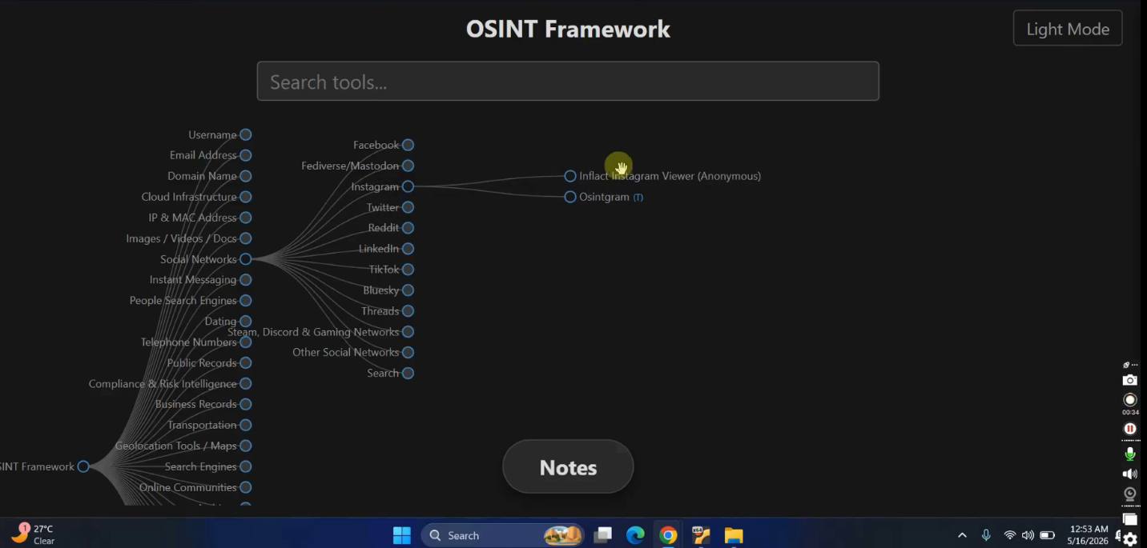

Learning Outcomes
• Learned ethical hacking fundamentals
• Improved knowledge of web security
• Gained practical experience with Kali Linux
• Learned project deployment using Vercel
• Improved vulnerability assessment skills
Tools to Create the Report
Easy Options
- Canva
- Google Docs
- Microsoft Word

Upload Final Report
You can upload the PDF to:
- GitHub
- LinkedIn
- ORCID
- Portfolio Website
Future Enhancements
• Add real-time threat detection
• Improve dashboard analytics
• Integrate AI-based monitoring
• Add advanced authentication features
• Enhance reporting system
Conclusion
This internship provided valuable practical exposure to cybersecurity concepts, ethical hacking tools, and deployment processes. The project improved technical knowledge, problem-solving abilities, and understanding of web application security.

